## COLLEGE BUS MANAGEMENT SYSTEM

A Mini Project Report Submitted by

### SREENANDHANA C (KITM24MCA-2026)

### TO

The APJ Abdul Kalam Technological University in partial fulfilment of the Requirement for the award of the degree

Of

Master of Computer Applications



### Department of Computer Applications

KMCT Institute of technology and management Kuttipuram,

Malappuram - 679571.

### DECLARATION

I, the undersigned, hereby declare that the project report “College Bus Management System”, submitted for partial fulfillment of the requirements for the award of the degree of Master of Computer Applications of the APJ Abdul Kalam Technological University, Kerala, is a bona fide work done by me under the supervision of Aswathi nair , Assistant Professor, Department of Computer Applications. This report represents my own work, and where ideas or words of others have been used, they have been properly cited and referenced. I also declare that I have adhered to the ethics of academic honesty and integrity, and this work has not been submitted earlier for the award of any degree or diploma in any other institution or university.

# DEPARTMENT OF COMPUTER APPLICATIONS

KMCT INSTITUTE OF TECHNOLOGY & MANAGEMENT,

KUTTIPURAM



CERTIFICATE

This is to certify that the report entitled **COLLEGE BUS MANAGEMENT SYSTEM** is a bonafide record of the Mini Project work during the year 2024-25 carried out by **SREENANDHANA C (KITM24MCA-2026)** submitted to the APJ Abdul Kalam Technological University, in partial fulfillment of the requirements for the award of the Master of Computer Applications, under my guidance and supervision. This report in any form has not been submitted to any other University or Institution for any purpose .

Internal Supervisor(s) External Supervisor(s)

Head of The Department

# Acknowledgements

At the very outset, I would like to thank the Almighty for His blessings and mercy towards me over the years. I wish to express my sincere gratitude to my project guide, Ms. Aswathi Nair, Department of Master of Computer Applications, for her valuable suggestions, guidance, constant encouragement, constructive comments, and motivation extended to me throughout the course of this project work. Her support has been instrumental in the successful completion of this project. I would also like to extend my sincere thanks to all the faculty members of the Department of Master of Computer Applications for their support and valuable suggestions during the course of my project. Last but not least, my heartfelt thanks to my parents, friends, and all those who supported me directly or indirectly during the completion of this project.

# Abstract

The College Bus Management System is a web-based application developed to simplify and automate the management of college transportation services. Traditionally, bus operations such as student registration, route allocation, fee collection, and driver assignment were handled manually, which often led to errors, inefficiency, and data mismanagement .The proposed system addresses these issues by providing an integrated platform for Admin, Driver, and Student. The Admin can manage buses, routes, student details, and fees; the Driver can view assigned routes and student information; and the Student can register for bus services, view route details, and make payments. This ensures transparency, security, and efficiency in the transportation system .The project is implemented using modern web technologies with a structured database for data storage, retrieval, and management. By automating critical operations, the system reduces manual workload, improves accuracy, and provides better service to students and staff. This system can be further enhanced with features such as GPSbased live tracking, mobile app support, and online payment gateways, making it a complete solution for college bus management.

### Contents

**Declaration** **Certificate** **Acknowledgements** **Abstract**

**Contents**

**List** **of** **Figures**

1. **Introduction**
   1. Background …………………………………………………………………
   2. Components…………………………………………………
   3. Motivation…………………………………
   4. Objective………………………………………
   5. Contribution……………………
   6. Report Organization…………………………………………………
2. **Existing** **System**
3. **Methodology**

1. **Design**
2. **Conclusions**

**APPENDIX**

Source code

### List Of Figures

Project Plan Product Backlog

Data Flow Diagram ER Diagram

Result

**Chapter** **1**

### Introduction

College Bus Management System is a web-based application designed to provide a simple and efficient platform for managing college transportation services. The system helps automate various activities such as student registration for bus services, route allocation, driver management, and fee collection, ensuring a smooth and organized operation of the college bus system.The system allows administrators to add and manage bus details, assign routes, and monitor student registrations, while students can view available routes, register for the bus service, and check their payment status online. This eliminates the need for manual record-keeping and reduces the chances of errors and delays. Developed using Python, Flask, HTML, CSS,JAVA SCRIPT and MySQL, the application offers a user-friendly interface, secure data management, and easy access for all users. The system enhances coordination between the admin, drivers, and students, making the transportation process more transparent and reliable.By digitizing bus operations, the College Bus Management System ensures convenience, accuracy, and efficiency in managing the overall transportation process within the institution.

### Background

Transportation plays an essential role in the daily functioning of educational institutions. However, traditional methods of managing college bus services often involve manual recordkeeping, paper-based registrations, and communication gaps between administrators, drivers, and students. These manual systems can lead to errors, inefficiency, and a lack of transparency. With the advancement of digital technology, web-based management systems have become a convenient and reliable solution for automating college transportation. The College Bus Management System was

developed to simplify and modernize this process by providing an online platform where administrators can manage buses, routes, and drivers, while students can register for services and view route details efficiently This system ensures better coordination, reduces manual workload, and provides a transparent and user-friendly interface for managing college transportation services.

### Components

The College Bus Management System consists of three main components: the Client, Middleware, and Database. The Client is a web-based interface developed using HTML, CSS, and JavaScript, which enables administrators, students, and drivers to interact with the system. Through this interface, students can register for bus services, view route details, and pay fees online. Administrators can manage buses, routes, and drivers, while drivers can access assigned route and schedule details. The Middleware, implemented using Python Flask, acts as the web server and serves as a bridge between the client and the database. It handles core operations such as login authentication, registration, route allocation, fee processing, and report generation. It ensures that all business rules are properly executed and that data flows securely between users and the database. The Database, developed using MySQL, stores and manages all essential data including student details, driver profiles, bus information, route sched2ules, and payment records. It maintains data consistency, integrity, and security across the system. This three-tier architecture ensures smooth communication between all components, making the system efficient, secure, and easy to maintain

### Motivation

Traditional management of college bus services often relies on manual record-keeping and paper-based processes, which can lead to confusion, data loss, and inefficiency. Handling student registrations, fee collection, and route assignments manually consumes a significant amount of time and effort for both students and administrators. As the number of students and buses increases, managing transportation details becomes more complex, making it difficult to maintain accuracy and coordination.Students often face issues in accessing updated route information or verifying fee payments, while administrators struggle to track bus allocations and schedules efficiently. With the advancement of web technologies and the growing demand for automation in educational institutions, there is a strong need for a **user-friendly,** **centralized,** **and** **transparent** **system** that simplifies bus management. The **College** **Bus** **Management** **System** was developed to address these challenges by providing a digital platform that connects students, drivers, and administrators effectively, ensuring convenience, accuracy, and better communication.

### Objective

* + - Provide an efficient and automated platform for managing college transportation services.
    - Allow students to register for bus services, view routes, and pay transportation fees online.
    - Enable administrators to add and manage bus details, assign routes, and monitor driver activities.
    - Offer drivers access to their assigned routes, student lists, and schedules through an easy-to-use interface.
    - Reduce manual errors and paperwork by maintaining all transportation data in a centralized database.
    - Ensure secure login and role-based access for administrators, drivers, and students.
    - Provide a user-friendly dashboard for smooth navigation and efficient management of bus operations.
    - Ensure real-time updates and availability of bus and route information for all users.

### Contribution

College Bus Management System contributes by providing an integrated digital platform that simplifies and automates the management of college transportation services. It enables administrators to efficiently manage buses, routes, drivers, and student registrations through a single, user-friendly system. The application allows students to easily register for bus services, view assigned routes, and pay their transportation fees online, thereby reducing manual work and ensuring greater transparency. Drivers can access their schedules, route details, and student lists in real-time, improving coordination and reliability. By incorporating secure login, role based access, and centralized data management, the system ensures data integrity and protection. It minimizes human error, eliminates redundant paperwork, and enhances operational efficiency. Overall, the College Bus Management System enhances communication between students, drivers, and administrators, offering a modern, transparent, and convenient approach to managing college transportation effectively.

### Report Organization

The project report for QuickDrive – Rental Car Management System is divided into several sections. Section 1 includes the title page, certificate, acknowledgements, and abstract. Section 2 describes the introduction, existing system, and proposed system. Section 3 presents the objectives, scope, and system analysis. Section 4 explains system design, implementation, and database design. Section 5 covers testing and contribution. Finally, Section 6 provides the conclusion, references, and appendices.

## Chapter 2

### Existing System

In the existing college bus management system, transportation is often handled manually or through basic records, which makes the process inefficient and prone to errors. Students and staff usually have no centralized platform to check bus schedules, routes, or real-time bus locations. Communication regarding bus timings or delays is often done manually, through notices or verbal announcements, leading to inconvenience and confusion. Bus drivers manage routes using paper logs or personal knowledge rather than a systematic tool, which makes tracking difficult.

Some key problems in the existing system include:

* + - There is no centralized platform for students and staff to view bus schedules, routes, or seat availability easily.
    - Tracking of buses in real-time is not available, leading to uncertainty about arrival times.
    - Communication between administration, drivers, and students is inefficient and manual.
    - Booking of seats (if applicable) is not automated, making it difficult to manage capacity.
    - There is no system to monitor driver performance, bus maintenance, or safety compliance.
    - Payment or fee records for bus services (if applicable) are maintained manually, causing delays and errors.
    - The system does not encourage efficient use of idle vehicles, limiting the sharing economy.

## Chapter 3 Methodology

### Introduction

After analyzing the requirements of the College Bus Management System, it was found that the Agile model of software development is most suitable for this project. Agile methodology emphasizes adaptability and client involvement, allowing the system to be developed in small, manageable modules. Since this project involves multiple functionalities such as user registration, bus and route management, driver assignment, student seat allocation, online monthly pass payments, and feedback management, these requirements can be implemented in iterations, enabling gradual improvements and effective handling of changes. Among Agile methods, Scrum is selected as the framework for managing the development process. Scrum provides a flexible structure that supports complex product development, focusing on lean software practices and effective collaboration. Agile promotes adaptability, continuous feedback, and iterative improvement, ensuring that the College Bus Management System can be developed efficiently while incorporating user feedback to enhance usability, performance, and functionality.

### Workflow

The workflow of the College Bus Management System begins with **user** **registration**, where students, teachers, drivers, and the admin create accounts with their personal details. After registration, users log in to their respective dashboards according to their roles. The admin can manage buses by adding, updating, or removing bus details such as bus number, capacity, and assigned driver. They can also manage routes by defining source, destination, stops, andtimings. Additionally, the admin can view student seat allocations, manage drivers, and review complaints or feedback . Students and teachers can view available bus routes, timings ,and stop details. They can request or book monthly passes for buses online and make payments through the system. Users can also provide feedback or complaints related to the bus service. Drivers can view their assigned bus details, routes, schedules, and stops. They can update trip statuses such as started, in-progress, or completed . Once a monthly pass request or seat allocation is processed, the system updates the allocation and payment records. Complaints and feedback are tracked and addressed by the admin. This workflow makes the entire bus management process organized, efficient, and transparent while ensuring convenience for students and faculty.

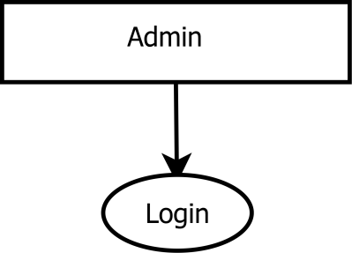

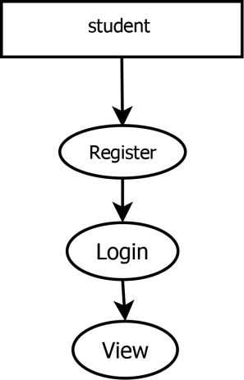

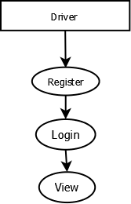

## 3.3 User story

|  |  |  |  |
| --- | --- | --- | --- |
| ID | ACTOR | DESCRIPTION | PURPOSE/BENIFIT |
| US01 | Student | Register an account | Create personal profile and access bus services |
| US02 | Student | Login with username and password | Security access my account and bus details |
| USO3 | Student | View available bus routes | Select suitable route based on pickup and destination |
| US04 | User | View driver and bus details | Identify driver, contact information, and timing |
| USO5 | User | Track bus location in real time | Know the exact bus location and arrival time |
| US06 | User | Submit feedback or complaints | Share my experience or report issues for improvement |
| US07 | Admin | Manage student registrations | Approve or reject student accounts for bus services |
| US08 | Admin | Add , update , or delete bus routes | Keep route details up to date |
| US09 | Admin | View and manage feedback | Monitor user feedback  and improve service quality |
| US10 | Driver | View route and students | Know route details number of students |
| US11 | Driver | Update current bus location | Share real-time location with students and admin |
| US12 | Driver | Approve students | Approve by verifying payments |

## 3.4 Product backlog

|  |  |  |  |  |  |
| --- | --- | --- | --- | --- | --- |
| **ID** | **PRIORITY** | **SIZE(HOURS)** | **SPRINT** | **STATUS** | **NAME** |
| 1 | Medium | 4 | 1 | Planned | Registration |
| 2 | Medium | 4 |  | Planned | Login |
| 3 | High | 10 | 2 | Partially completed | Table Design |
| 4 | High | 22 | 3 | Planned | Coding |
| 5 | Medium | 10 | 4 | Planned | Testing Data |
| 6 | High | 5 | 5 | Planned | Output generation |

## 3.5 Project plan

|  |  |  |  |  |  |
| --- | --- | --- | --- | --- | --- |
| **USER STORY**  **ID** | **SPRINT** | **START DATE** | **END DATE** | **HOURS** | **STATUS** |
| 4,5,8,9 | Sprint 1 | 01/07/2025 | 18/07/2025 | 11 | Complete |
| 1,2,3 | Sprint 2 | 23/07/2025 | 30/07/2025 | 5 | Complete |
| 10,11 | Sprint 3 | 01/08/2025 | 24/10/2025 | 14 | Complete |
| 12 | Sprint 4 | 09/09/2025 | 26/09/2025 | 12 | Complete |
| 6,7 | Sprint 5 | 03/10/2025 | 24/10/2025 | 14 | Complete |

## 3.6 Sprint backlog

Sprint 1:

|  |  |  |  |  |  |  |  |  |  |  |
| --- | --- | --- | --- | --- | --- | --- | --- | --- | --- | --- |
| Backlog item | Status and completion date | Original estimate in hours | Day  1  04/07 | Day  2 05/07 | Day 3 06/07 | Day  4  09/07 | Day 5 11/07 | Day  6  16/07 | Day 7 17/07 | Day  8  19/07 |
| Form  Design | 02/07 | 2 | 1 | 1 | 0 | 0 | 0 | 0 | 0 | 0 |
| Table  Design | 04/07 | 2 | 0 | 0 | 2 | 0 | 0 | 0 | 0 | 0 |
| Coding | 08/07 | 5 | 0 | 0 | 0 | 1 | 2 | 1 | 0 | 1 |
| Testing & validation | 08/07 | 2 | 0 | 0 | 0 | 0 | 0 | 0 | 1 | 1 |
| Total |  | 11 | 1 | 1 | 2 | 1 | 2 | 1 | 1 | 2 |

Sprint 2:

|  |  |  |  |  |  |  |
| --- | --- | --- | --- | --- | --- | --- |
| Backlog item | Status and completion date | Original estimate in hours | Day  1  23/07 | Day  2  25/07 | Day  3  29/07 | Day  4  30/07 |
| Coding | 29/07 | 2 | 1 | 0 | 1 | 0 |
| Testing & validation | 30/07 | 3 | 0 | 2 | 0 | 1 |
| Total |  | 5 | 1 | 2 | 1 | 1 |

Sprint 3:

|  |  |  |  |  |  |  |  |  |  |  |  |  |  |
| --- | --- | --- | --- | --- | --- | --- | --- | --- | --- | --- | --- | --- | --- |
| Backl og item | Status and compl  etion date | Ori gina  l  esti mat  e in hou  rs | Day  1  05/  08 | Day  2  06/  08 | Day  3  07/  08 | Day  4  08/  08 | Day  5  11/  08 | Day  6  12/  08 | Day  7  13/  08 | Day  8  14/  08 | Day  9  22/  08 | Day  10  26/  08 | Day  11  27/  08 |
| Form Desig n | 01/08 | 2 | 2 | 0 | 0 | 0 | 0 | 0 | 0 | 0 | 0 | 0 | 0 |
| Table Desig n | 06/08 | 2 | 0 | 1 | 1 | 0 | 0 | 0 | 0 | 0 | 0 | 0 | 0 |
| Codin  g | 26/08 | 8 | 0 | 0 | 0 | 2 | 1 | 1 | 1 | 1 | 1 | 1 | 0 |
| Testin  g &  validat ion | 27/08 | 2 | 0 | 0 | 0 | 0 | 0 | 0 | 0 | 0 | 1 | 0 | 1 |
| Total |  | 14 | 2 | 1 | 1 | 2 | 1 | 1 | 1 | 1 | 2 | 1 | 1 |

Sprint 4:

|  |  |  |  |  |  |  |  |  |  |  |  |
| --- | --- | --- | --- | --- | --- | --- | --- | --- | --- | --- | --- |
| Backl og item | Status and completio n date | Original estimate in hours | Day  1  09/0  9 | Day  2  10/0  9 | Day  3  12/0  9 | Day  4  16/0  9 | Day  5  17/0  9 | Day  6  19/0  9 | Day  7  23/0  9 | Day  8  24/0  9 | Day  9  26/0  9 |
| Form Desig n | 10/09 | 2 | 1 | 1 | 0 | 0 | 0 | 0 | 0 | 0 | 0 |
| Codin  g | 26/09 | 8 | 0 | 0 | 2 | 1 | 1 | 2 | 1 | 0 | 1 |
| Testin  g &  validat ion | 26/09 | 2 | 0 | 0 | 0 | 0 | 0 | 0 | 0 | 1 | 1 |

Sprint 5:

|  |  |  |  |  |  |  |  |  |  |  |  |  |
| --- | --- | --- | --- | --- | --- | --- | --- | --- | --- | --- | --- | --- |
| Backl og item | Status and compl  etion date | Ori gin  al esti mat  e in hou  rs | Day  1  03/  10 | Day  2  07/  10 | Day  3  08/  10 | Day  4  10/  10 | Day  5  14/  10 | Day  6  15/  10 | Day  7  17/  10 | Day  8  121/  10 | Day  9  22/  10 | Day  10  24/  10 |
| Form Desig n | 03/10 | 2 | 2 | 0 | 0 | 0 | 0 | 0 | 0 | 0 | 0 | 0 |
| Table Desig n | 08/10 | 2 | 0 | 1 | 1 | 0 | 0 | 0 | 0 | 0 | 0 | 0 |
| Codin  g | 24/10 | 8 | 0 | 0 | 0 | 2 | 1 | 1 | 2 | 1 | 0 | 1 |
| Testin  g &  validat ion | 24/10 | 2 | 0 | 0 | 0 | 0 | 0 | 0 | 0 | 0 | 1 | 1 |
| Total |  | 14 | 2 | 1 | 1 | 2 | 1 | 1 | 2 | 1 | 1 | 2 |

## Chapter 4

### Result

## 4.2 Data Flow Diagram

**Level** **0**

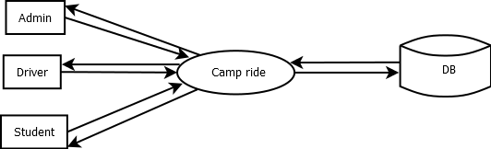

**Level** **1**

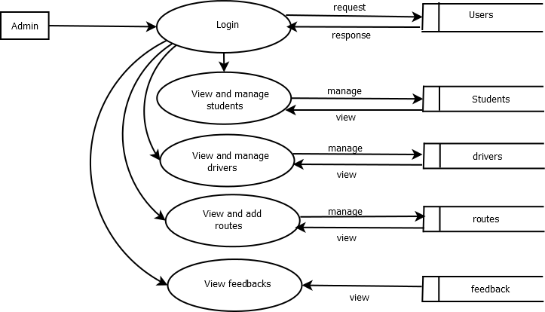

**Level** **2**

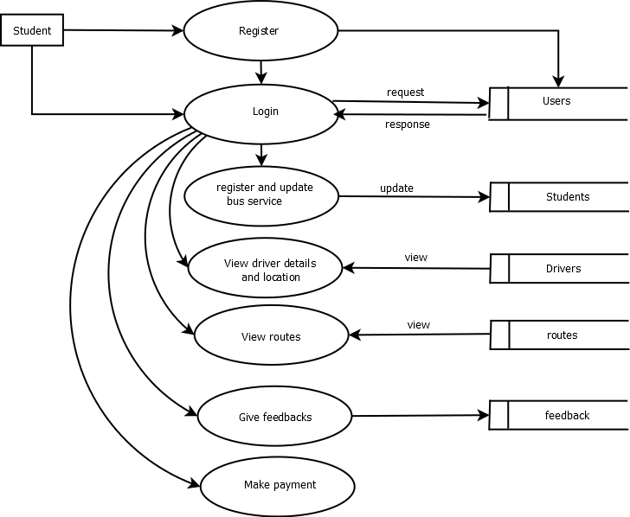

**Level 3**

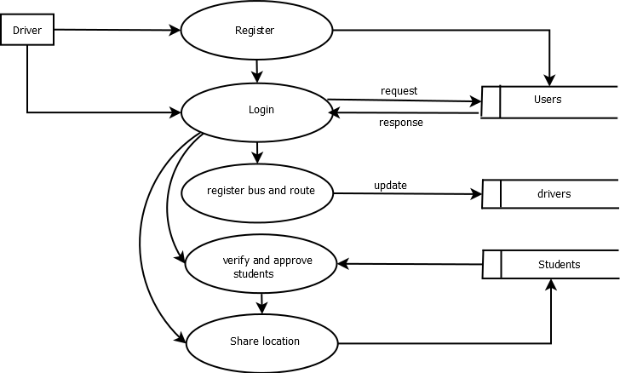

**ER** **Diagram**

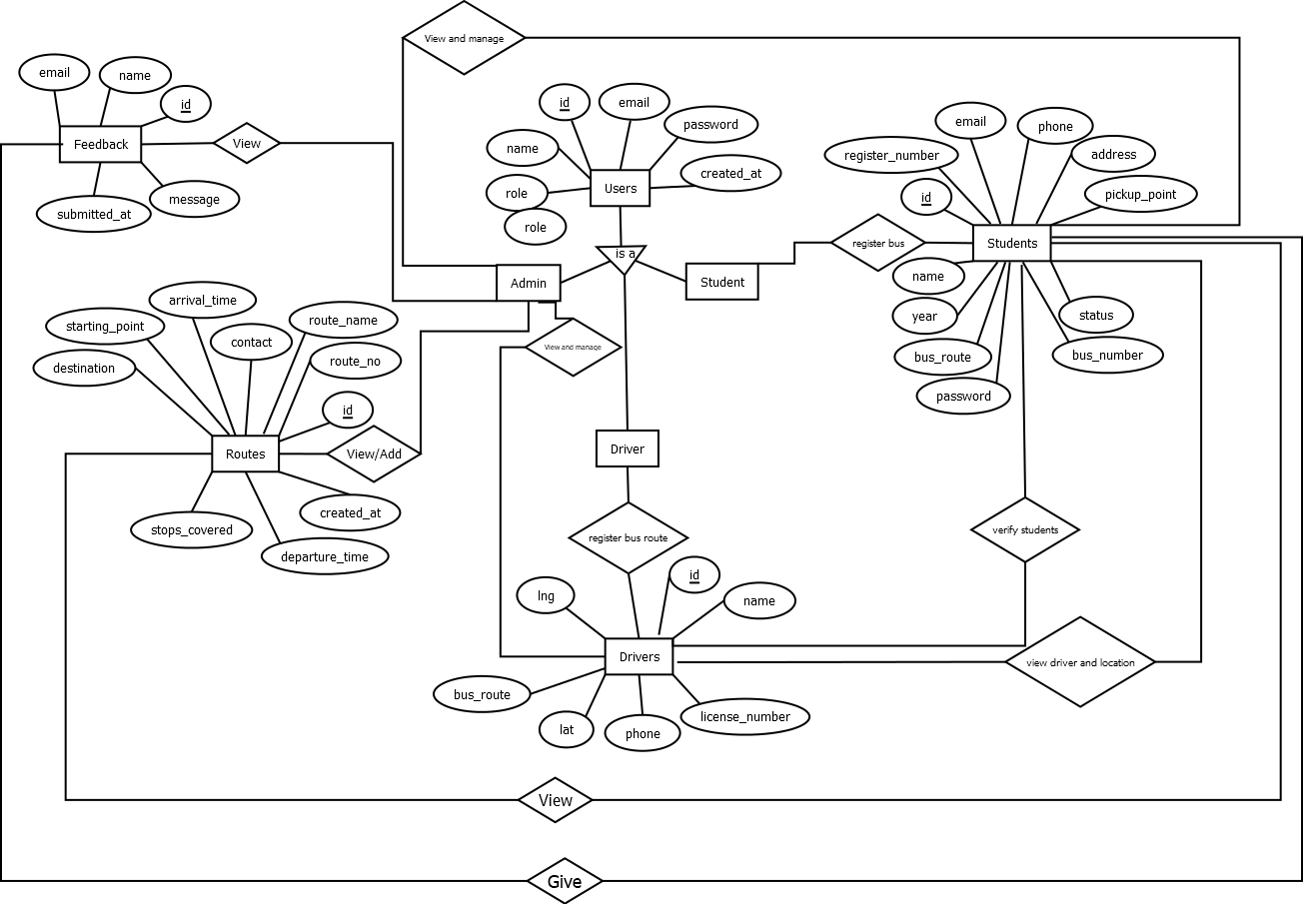

## Tables

### STUDENT

|  |  |  |
| --- | --- | --- |
| **Field** **name** | **Data** **Type** | **Description** |
| Student _id(pk) | Int | Unique id for each student |
| Name | Varchar(100) | Student’s full name |
| Register_number | Varchar(50) | Rollno/register no |
| Department | Varchar(100) | Branch |
| Year | Int | Year of study |
| Contact_no | Varchar(15) | Students phone number |
| Address | Varchar(255) | Residential address |
| Bus number | Int | Allocated bus |
| Pickup_point | varchar | Allocated bus stop |
| Bus_route | varchar | route |
| status | varchar | View status |

Routes

|  |  |  |
| --- | --- | --- |
| **Field** **name** | **Data** **Type** | **Description** |
| Rout_id | Int | Unique id for route |
| Route_name | Varchar(100) | Route name |
| Start_point | Varchar(100) | Starting location |
| End_point | Varchar(100) | Ending location |
|  |  |  |
| Distance_km | Decima(5,2) | Total distance in kilometers |

SCHEDULE TABLE

|  |  |  |
| --- | --- | --- |
| Field name | Data type | Description |
| Schedule_id(pk) | Int | Unique schedule id |
| Bus_id(fk) | Int | Bus assigned |
| Route_id(fk) | Int | Routeassigned |
| Deperature_time | Time | Deperature time |
| Arrival_time | Time | Arrival time |
| Date | Date | Schedule date |

FEEDBACK TABLE

|  |  |  |
| --- | --- | --- |
| FIELD NAME | DATA TYPE | DESCRIPTION |
| id | Int | Unique admin id |
| name | Varchar(50) | Student id |
| message | Varchar(255) | Feedback message |
| Email | Varchar(100) | Contact email |
| Submitted_at | timestamp | Registering for the bus service |

DRIVER TABLE

|  |  |  |
| --- | --- | --- |
| FIELD NAME | DATA TYPE | DESCRIPTION |
| Driver_id(pk) | Int | Unique id for driver |
| Name | Varchar(100) | Driver’s full name |
| License_no | Varchar(50) | Driving license number |
| Contact_no | Varchar(15) | Drivers pjone number |
| Bus_number | Varchar(255) | Dresidential address |
| Bus_route | varchar | The route allocated to the driver’s bus. |
| lat | decimal | Current latitude position of the driver/bus (for live tracking). |
| ing | decimal | Current latitude position of the driver/bus (for live tracking). |

## Chapter 5

### Conclusion

The *College* *Bus* *Management* *System* successfully streamlines and automates the management of college transportation services, replacing traditional manual processes with an efficient, reliable, and user-friendly web-based platform. By integrating functionalities for Admin, Driver, and Student, the system ensures smooth coordination among all stakeholders. It enhances data accuracy, minimizes human error, and improves overall operational efficiency.

The system effectively handles key tasks such as student registration, route allocation, fee management, and driver assignment, ensuring transparency and accountability in every process. Its structured database design allows for secure data storage and easy retrieval, contributing to better decision-making and administrative control.

In conclusion, the project demonstrates the importance of technology in improving institutional operations. With potential future enhancements like GPS-based tracking, mobile app integration, and online payment gateways, the *College* *Bus* *Management* *System* can evolve into a comprehensive and scalable transportation management solution for educational institutions

### References

* **Book:** *Flask* *Web* *Development:* *Developing* *Web* *Applications* *with* *Python* by Miguel Grinberg, O’Reilly Media.
* **Book:** *Database* *System* *Concepts* by Abraham Silberschatz, Henry F. Korth, and S. Sudarshan, McGraw Hill.
* **Book:** *Web* *Technologies:* *HTML,* *CSS,* *JavaScript,* *PHP,* *Java,* *JSP,* *XML,* *and* *AJAX* by Uttam K. Roy, Oxford University Press.
* **Book:** *Transportation* *Systems* *Technology* *and* *Integrated* *Management* by Ram Krishna Upadhyay et al., Springer.
* **Wikipedia** **–** **Bus** **Transport** **–** https://en.wikipedia.org/wiki/Bus_transport
* **Flask** **Documentation** **–** https://flask.palletsprojects.com
* **SQLite** **Documentation** **–** https://[www.sqlite.org/docs.html](http://www.sqlite.org/docs.html)
* **TutorialsPoint** **–** **Flask** **Tutorial** **–** https://[www.tutorialspoint.com/flask/](http://www.tutorialspoint.com/flask/)
* **W3Schools** **–** **HTML,** **CSS,** **JavaScript** **Basics** **–** https://[www.w3schools.com](http://www.w3schools.com/)
* **GeeksforGeeks** **–** **Python** **and** **Flask** **Programming** **–** https://[www.geeksforgeeks.org](http://www.geeksforgeeks.org/)
* **Research** **papers** **and** **online** **tutorials** **related** **to** **transportation** **management** **systems,** **database** **management,** **and** **web** **application** **development.**

# Appendix

**Source** **Code**

### Login.html

### <!DOCTYPE html>

### <html lang="en">

### <head>

### <meta charset="UTF-8">

### <meta name="viewport" content="width=device-width, initial-scale=1.0">

### <title>Login - College Bus Management</title>

### <link rel="stylesheet" href="{{ url_for('static', filename='css/style.css') }}">

### <style>

### body {

### font-family: Arial, sans-serif;

### background: linear-gradient(135deg, #17a2b8, #17a2b8);

### height: 100vh;

### display: flex;

### align-items: center;

### justify-content: center;

### margin: 0;

### }

### .card {

### background: white;

### padding: 30px;

### border-radius: 12px;

### box-shadow: 0 8px 20px rgba(0,0,0,0.15);

### width: 100%;

### max-width: 350px;

### text-align: center;

### }

### h2 {

### margin-bottom: 20px;

### color: #333;

### }

### label {

### display: block;

### text-align: left;

### font-weight: bold;

### margin: 8px 0 4px;

### }

### input {

### width: 100%;

### padding: 10px;

### border: 1px solid #ddd;

### border-radius: 6px;

### margin-bottom: 15px;

### outline: none;

### transition: border-color 0.3s;

### }

### input:focus {

### border-color: #17a2b8;

### ;

### }

### button {

### width: 100%;

### padding: 10px;

### background: #17a2b8;;

### color: white;

### font-size: 16px;

### border: none;

### border-radius: 6px;

### cursor: pointer;

### transition: background 0.3s;

### }

### button:hover {

### background: #17a2b8;

### }

### .link {

### margin-top: 12px;

### font-size: 14px;

### }

### .link a {

### color: #17a2b8;

### text-decoration: none;

### }

### .link a:hover {

### text-decoration: underline;

### }

### </style>

### </head>

### <body>

### <div class="card">

### <h2>Login</h2>

### <form method="POST" action="/login">

### <div class="flash-messages">

### {% with messages = get_flashed_messages() %}

### {% if messages %}

### {% for message in messages %}

### <div class="flash">{{ message }}</div>

### {% endfor %}

### {% endif %}

### {% endwith %}

### </div>

### <label>User name:</label>

### <input type="text" name="name" placeholder="Enter your username" required>

### <label>Password:</label>

### <input type="password" name="password" placeholder="Enter your password" required>

### <button type="submit">Login</button>

### </form>

### <div class="link">

### Don't have an account? <a href="/register">Sign up</a>

### </div>

### </div>

### </body>

### </html>

### Student.html

### {% extends "index.html" %}

### {% block content %}

### <!-- Student Dashboard Content -->

### <div class="container my-5">

### <div class="text-center mb-4">

### <h2>Welcome, {{ name }}!</h2>

### <p class="text-muted">Manage your bus services easily with CAMP RIDE.</p>

### </div>

### <div class="row">

### <div class="col-md-4 mb-4">

### <div class="card shadow-sm border-0">

### <div class="card-body text-center">

### <i class="fa fa-bus fa-3x text-primary mb-3"></i>

### <h5 class="card-title">View Routes</h5>

### <p class="card-text">Check your bus timings and assigned routes.</p>

### <a href="{{ url_for('view_routes') }}" class="btn btn-primary">View</a>

### </div>

### </div>

### </div>

### <div class="col-md-4 mb-4">

### <div class="card shadow-sm border-0">

### <div class="card-body text-center">

### <i class="fa fa-clipboard-list fa-3x text-primary mb-3"></i>

### <h5 class="card-title">Register Bus</h5>

### <p class="card-text">Register or update your bus service request.</p>

### <a href="{{ url_for('bus_registration') }}" class="btn btn-primary">Register</a>

### </div>

### </div>

### </div>

### <div class="col-md-4 mb-4">

### <div class="card shadow-sm border-0">

### <div class="card-body text-center">

### <i class="fa fa-comments fa-3x text-primary mb-3"></i>

### <h5 class="card-title">Feedback</h5>

### <p class="card-text">Submit feedback or complaints to admin.</p>

### <a href="{{ url_for('feedback') }}" class="btn btn-primary">Submit</a>

### </div>

### </div>

### </div>

### </div>

### <!-- Live Location Map -->

### <div class="row mt-5">

### <div class="col-md-12">

### <div class="card p-3">

### <h4>Driver Live Location</h4>

### <div id="map" style="height: 400px;"></div>

### </div>

### </div>

### </div>

### </div>

### <!-- Leaflet CSS & JS -->

### <link rel="stylesheet" href="https://unpkg.com/leaflet/dist/leaflet.css" />

### <script src="https://unpkg.com/leaflet/dist/leaflet.js"></script>

### <!-- Socket.IO -->

### <script src="https://cdn.socket.io/4.6.1/socket.io.min.js"></script>

### <script>

### const socket = io();

### // Join driver's room

### socket.emit("join_room", { driver_id: "{{ driver_id }}" });

### // Initialize map

### var map = L.map('map').setView([9.9312, 76.2673], 13); // default coords

### L.tileLayer('https://{s}.tile.openstreetmap.org/{z}/{x}/{y}.png', {

### attribution: '© OpenStreetMap contributors'

### }).addTo(map);

### var marker = L.marker([9.9312, 76.2673]).addTo(map).bindPopup("Driver Location");

### // Listen for location updates

### socket.on("location_update", (data) => {

### if (data.driver_id == "{{ driver_id }}") {

### const lat = parseFloat(data.lat);

### const lng = parseFloat(data.lng);

### marker.setLatLng([lat, lng]);

### map.setView([lat, lng], 15);

### }

### });

### socket.on("location_stop", (data) => {

### console.log("Driver stopped sharing location");

### });

### </script>

### {% endblock %}